1. What are the various elements of the Excel interface? Describe how

they're used.

The Excel interface consists of various elements that allow users to navigate, enter and manipulate data, and perform calculations. Here are the key elements of the Excel interface and their uses:

* Title Bar: The title bar is located at the top of the Excel window and displays the name of the workbook you are currently working on.
* Ribbon: The ribbon is a set of tabs at the top of the Excel window, such as Home, Insert, Page Layout, Formulas, Data, Review, and View. Each tab contains related commands organized into groups. For example, the Home tab contains commands for formatting, clipboard operations, and basic functions.
* Quick Access Toolbar: The Quick Access Toolbar is a customizable toolbar located above the ribbon or below the ribbon in Excel versions prior to 2013. It provides quick access to frequently used commands, such as Save, Undo, and Redo. You can customize this toolbar by adding or removing commands based on your preferences.
* Worksheet Tabs: Excel workbooks can contain multiple worksheets, and the worksheet tabs appear at the bottom of the Excel window. You can use these tabs to switch between different worksheets within the same workbook. By default, a new workbook contains three worksheets, but you can add or delete worksheets as needed.
* Formula Bar: The formula bar is located below the ribbon and displays the contents of the active cell. It is used to enter or edit formulas, functions, or data directly into cells.
* Columns and Rows: Excel organizes data in a grid format with columns labeled alphabetically (A, B, C, etc.) and rows labeled numerically (1, 2, 3, etc.). Columns are used to represent vertical sets of data, while rows are used to represent horizontal sets of data. Each intersection of a column and row is called a cell, which is the basic unit for entering and manipulating data.
* Cell: A cell is a rectangular box within a worksheet where you can enter and store data. It is identified by its column letter and row number (e.g., A1, B3). Cells are used to store values, formulas, and functions, and can be formatted to display specific types of data such as numbers, dates, or text.
* Name Box: The name box is located next to the formula bar and displays the cell reference of the active cell. You can also use the name box to define and navigate to named ranges in your worksheet.
* Scroll Bars: Excel provides vertical and horizontal scroll bars on the right and bottom sides of the worksheet to navigate through large datasets or when the entire worksheet doesn't fit on the screen.
* Status Bar: The status bar is located at the bottom of the Excel window and provides information about the current status of the workbook, such as the selected cell's mode (e.g., "Ready"), calculation mode, and other indicators like Caps Lock or Num Lock.

These are the key elements of the Excel interface that enable users to interact with data, perform calculations, and format worksheets effectively.

2. Write down the various applications of Excel in the industry.

Excel is widely used across various industries due to its versatility and powerful features. Here are some of the common applications of Excel in different industries:

* Finance and Accounting: Excel is extensively used in financial modeling, budgeting, and forecasting. It allows professionals to create complex financial models, track expenses, manage accounts payable and receivable, analyze financial data, and generate reports.
* Data Analysis: Excel is a popular tool for data analysis and manipulation. It offers functions, formulas, and tools that help analyze large datasets, perform statistical analysis, create charts and graphs, and generate insights. It is used for tasks such as data cleaning, sorting, filtering, and pivot tables.
* Project Management: Excel is used for project planning, scheduling, and tracking. It helps in creating Gantt charts, managing project timelines, tracking tasks, allocating resources, and monitoring progress. Excel's conditional formatting and data validation features are also beneficial in project management.
* Human Resources: Excel is utilized in HR departments for managing employee data, payroll calculations, attendance tracking, and performance evaluation. It can also be used for creating organizational charts, analyzing workforce trends, and generating reports related to employee metrics.
* Sales and Marketing: Excel is employed for sales forecasting, tracking sales data, managing customer databases, and analyzing marketing campaigns. It can be used to calculate sales targets, track leads and conversions, perform market segmentation, and generate reports for sales analysis.
* Inventory Management: Excel is commonly used for inventory management, stock control, and order tracking. It helps in maintaining product databases, monitoring stock levels, calculating reorder points, and generating inventory reports. Excel's conditional formatting and data validation features are valuable for managing inventory.
* Data Visualization: Excel allows users to create visually appealing charts, graphs, and dashboards to present data effectively. It offers a wide range of chart types and customization options, enabling users to showcase data trends, comparisons, and patterns.
* Research and Data Collection: Excel is used in research and data collection processes. It can be employed for creating data collection forms, organizing survey responses, analyzing research data, and generating summary statistics. Excel's data analysis features aid in deriving meaningful insights from collected data.
* Engineering and Manufacturing: Excel finds applications in engineering calculations, product design, and manufacturing processes. It can be used for performing calculations, analyzing engineering data, creating engineering models, and managing production schedules.
* Education and Academia: Excel is widely used in educational institutions for various purposes. It aids in grading and tracking student performance, creating lesson plans, analyzing educational data, and conducting research studies.

These are just a few examples of how Excel is applied across different industries. Its flexibility, computational power, and ease of use make it a valuable tool for numerous tasks, data management, and analysis in various professional settings.

3. On the ribbon, make a new tab. Add some different groups, insert

commands in the groups and name them according to their commands

added. Copy and paste the screenshot of the steps you followed.

Step 1: In the Customize the Ribbon window, under the list of tabs, click the **New Tab** button.

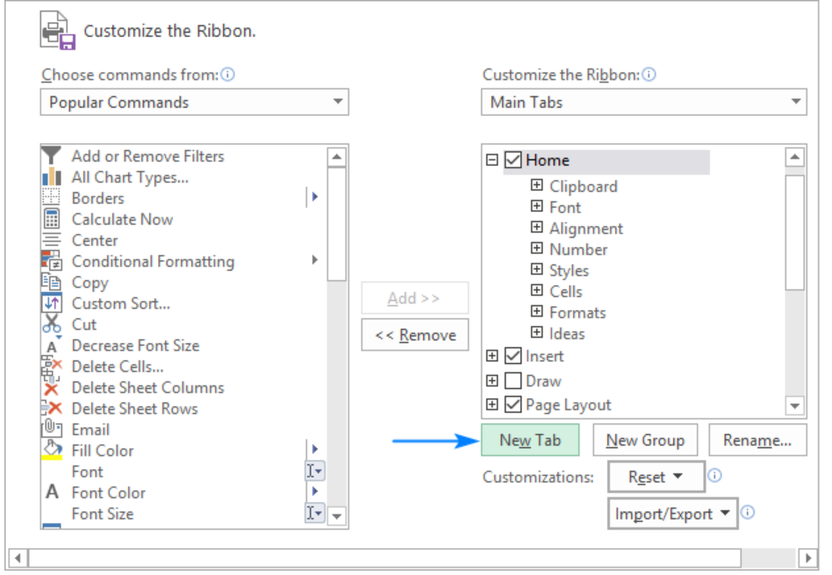

Step 2: Select the newly created tab, named New Tab (Custom), and click the **Rename…** button to give your tab an appropriate name. When done, click OK to save the changes.

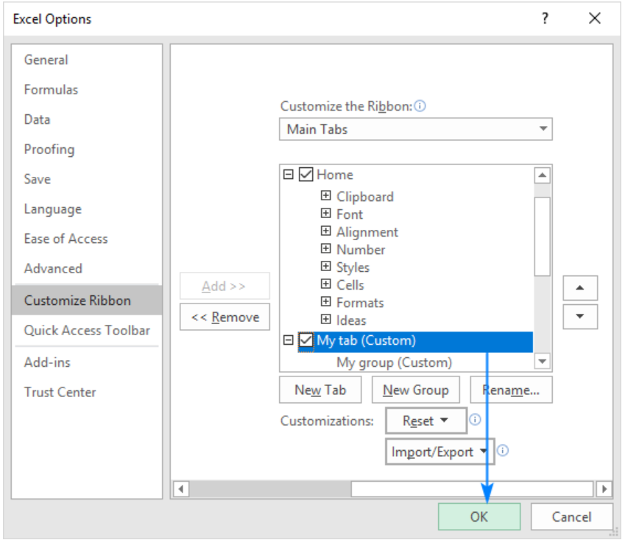

Step 3: In the right part of the Customize the Ribbon window, select the tab to which you'd like to add a new group.

Click the New Group button. This adds a custom group, named New Group (Custom), at the bottom of the list of groups, meaning the group displays on the far-right end of the tab. To create a new group in a specific location, select the group after which the new group is to appear.

Here, we're going to add a custom group to the end of the Home tab, so we select it, and click New Group:

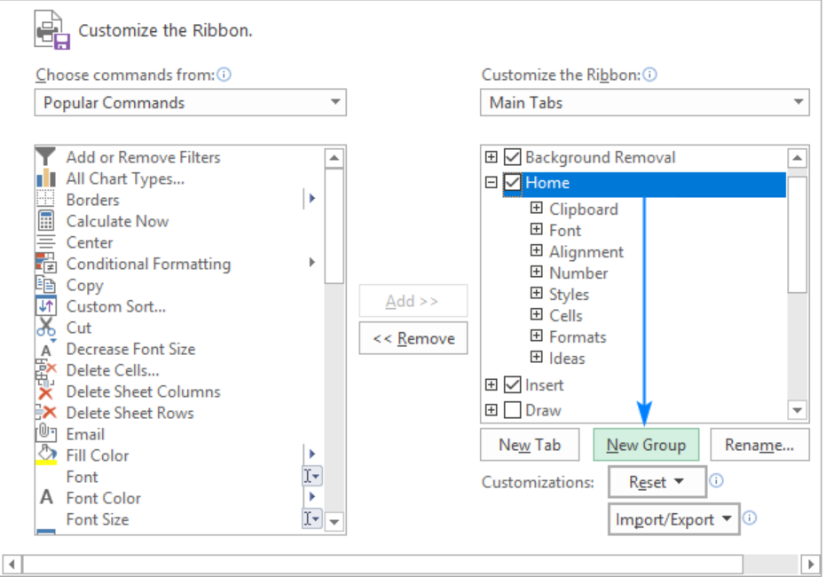

Step 4: In the list under Customize the Ribbon, select the target custom group.

In the Choose commands from drop-down list on the left, select the list from which you want to add commands, for example, Popular Commands or Commands Not in the Ribbon. In the list of commands on the left, click the command you want to add. Click the Add button. Click OK to save the changes. Here, we are adding add the Subscript and Superscript buttons to the custom tab that we created:

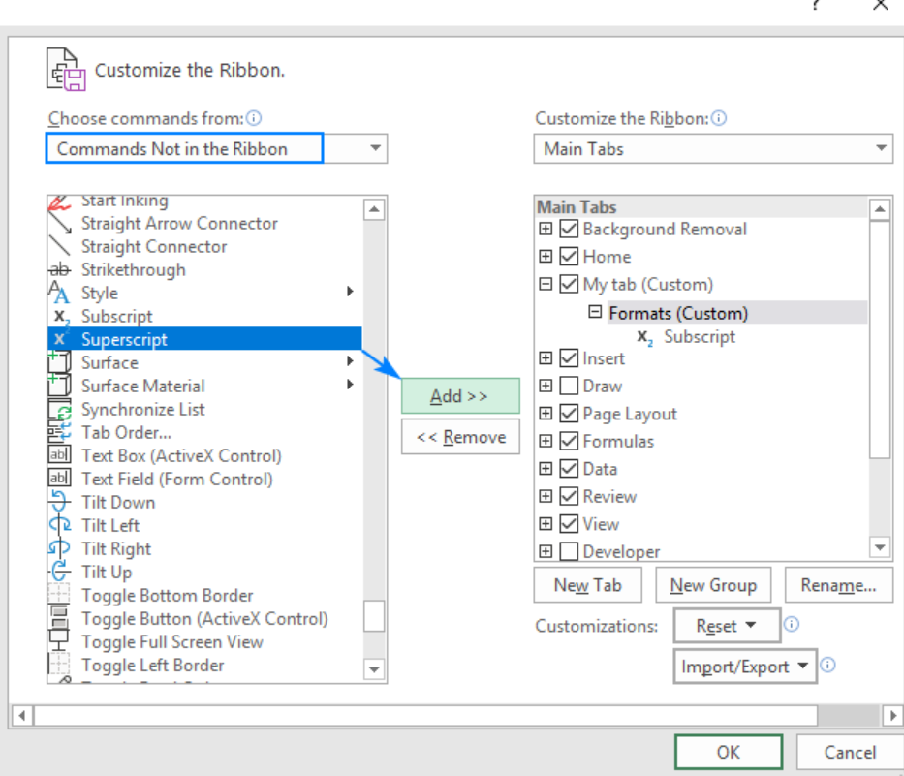

As the result, we now have a custom ribbon tab with two buttons:

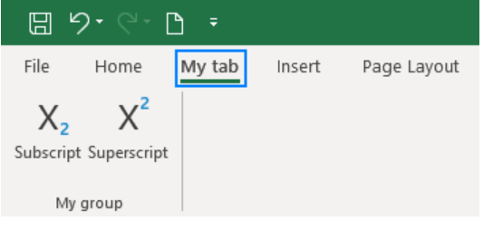

4. Make a list of different shortcut keys that are only connected to

formatting with their functions.

* Ctrl + B: Bold - Applies or removes bold formatting to the selected text or cell.
* Ctrl + I: Italic - Applies or removes italic formatting to the selected text or cell.
* Ctrl + U: Underline - Applies or removes underline formatting to the selected text or cell.
* Ctrl + 1: Format Cells - Opens the Format Cells dialog box, allowing you to customize the formatting of the selected cells.
* Ctrl + Shift + F: Font - Opens the Font dialog box, allowing you to change the font, font style, and font size.
* Ctrl + Shift + P: Font Size - Increases the font size of the selected text or cell.
* Ctrl + Shift + M: Decrease Font Size - Decreases the font size of the selected text or cell.
* Ctrl + Shift + 7: Border - Applies or removes a border around the selected cells.
* Ctrl + Shift + %: Percent Style - Applies percentage formatting to the selected cells.
* Ctrl + Shift + $: Currency Style - Applies currency formatting to the selected cells.
* Ctrl + Shift + #: Date Format - Applies the default date format to the selected cells.
* Ctrl + Shift + @: Time Format - Applies the default time format to the selected cells.
* Ctrl + Shift + !: Comma Style - Applies comma formatting to the selected cells.
* Ctrl + Shift + &: Apply Outline Border - Applies an outline border to the selected cells.
* Ctrl + Shift + _: Remove Border - Removes the border from the selected cells.
* Ctrl + Shift + ~: General Format - Applies the default number format to the selected cells.
* Ctrl + Shift + ^: Exponential Number Format - Applies exponential number formatting to the selected cells.
* Ctrl + Shift + *: Select Current Region - Selects the current region around the active cell.
* Ctrl + Shift + [: Group - Groups the selected rows or columns.
* Ctrl + Shift + ]: Ungroup - Ungroups the selected rows or columns.

5. What distinguishes Excel from other analytical tools?

Excel stands out from other analytical tools due to several distinguishing features:

* User-Friendly Interface: Excel has a familiar and user-friendly interface that makes it accessible to a wide range of users. Its spreadsheet format, grid structure, and simple navigation make it easy to enter, organize, and manipulate data without requiring extensive technical expertise.
* Versatility: Excel is a highly versatile tool that offers a wide range of functionalities. It can handle various tasks such as data entry, data analysis, calculations, modeling, charting, and reporting. It allows users to perform complex calculations, create dynamic charts, and automate tasks using formulas, functions, and macros.
* Accessibility and Availability: Excel is widely available and accessible, as it is a part of the Microsoft Office suite. It is installed on millions of computers and is commonly used in workplaces, educational institutions, and personal settings. Its widespread use ensures compatibility and ease of sharing files across different systems.
* Data Manipulation and Analysis: Excel provides robust tools for data manipulation and analysis. It offers a wide range of built-in functions, statistical analysis tools, and data visualization options. Users can sort, filter, and pivot data, perform complex calculations, apply conditional formatting, and create charts and graphs to analyze and present data effectively.
* Customization and Automation: Excel allows users to customize their worksheets and automate repetitive tasks. It provides extensive formatting options, conditional formatting, and the ability to create custom formulas and functions. Additionally, Excel's Visual Basic for Applications (VBA) enables users to automate tasks, create macros, and build interactive applications.
* Cost-Effectiveness: Excel is a cost-effective analytical tool, especially when compared to specialized software or programming languages. It offers a comprehensive set of features and functionalities at a relatively low price point. Its widespread use also ensures the availability of resources, tutorials, and support.
* Familiarity and Popularity: Excel has been around for decades and has become the de facto standard for spreadsheet applications. Its widespread popularity has led to a vast community of users, extensive online resources, and a large number of pre-built templates and add-ins available. This popularity makes it easier to find support and collaborate with others.
* While Excel excels in many areas, it does have limitations. It may not be suitable for handling extremely large datasets, complex statistical analysis, or advanced modeling scenarios. For such cases, specialized software or programming languages may be more appropriate. However, Excel's versatility and ease of use make it an essential analytical tool for a wide range of users and applications.

6. Create a table and add a custom header and footer to your table.

To create a table in Excel and add a custom header and footer to it, follow these steps:

1. Open Excel and open a new or existing worksheet.
2. Select the range of cells that you want to include in your table. This range should include all the data and headers you want to include in the table.
3. With the range selected, go to the "Insert" tab in the Excel ribbon.
4. In the "Tables" group, click on the "Table" button. Alternatively, you can use the shortcut key "Ctrl + T" to create a table.
5. Excel will automatically detect the range of cells you selected and display the "Create Table" dialog box. Ensure that the "Create Table" dialog box shows the correct range, and if necessary, adjust the range.
6. In the "Create Table" dialog box, check the box that says "My table has headers" if your selected range includes headers. This will use the first row of your selection as the header row in the table.
7. Click on the "OK" button in the "Create Table" dialog box. Excel will convert the selected range into a table with formatted borders and style.
8. Now that you have created the table, you can add a custom header and footer to it. Go to the "Design" tab in the Excel ribbon, which appears when you have the table selected.
9. In the "Table Styles" group, click on the "Header Row" dropdown arrow. Here you can choose from different predefined header row styles, or you can select "More Options" to customize the header style further.
10. To add a custom header to your table, click on the "Header/Footer" button in the "Table Styles" group. This will open the "Header/Footer" dialog box.
11. In the "Header/Footer" dialog box, you can enter your custom text in the "Left section," "center section," and "Right section" boxes to define the header content.
12. Similarly, you can enter your custom text in the "Left section," "center section," and "Right section" boxes in the "Footer" section to define the footer content.
13. After entering your custom header and footer text, click on the "OK" button in the "Header/Footer" dialog box.
14. The custom header and footer will now be applied to your table. You can view and adjust the header and footer by going to the "Print Preview" mode or by clicking on the "File" tab and selecting "Print" to see a preview of the printed table.